

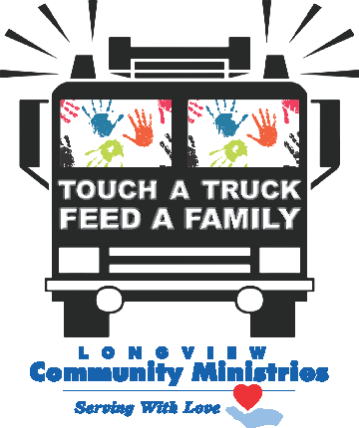Touch a Truck ~ Feed a Family Saturday, October 12, 2024

11 AM to 2 PM



Sponsor Information Sheet

# $5000 “Earth Mover” Donor

Premier Unlimited Reserved Space

Name and Logo on **ALL** printed materials and advertising Social Media recognition

XL signage at event

# $2500 “Monster” Donor

Unlimited Reserved Space

Name and Logo on **ALL** printed materials and advertising Social Media recognition

Large signage at event

# $1000 “Heavy Lifter” Donor

Logo on printed materials and advertising Acknowledgment on LCM social media and advertising at Longview Mall

# $500 “Front End Loader” Donor

Signage at event Acknowledgment on LCM social media

# Other Ways to Contribute

Vehicle Display Event Volunteers In-Kind Donation

For more information, email [events@lcmserves.org](mailto:events@lcmserves.org) or (903)753-3561